**R Code for Examples in the book**

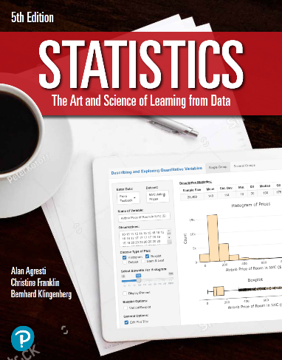

***“Statistics: The Art and Science of Learning from Data”***

**by Agresti, Franklin and Klingenberg, 5th edition**

**Chapter 8**

**Example 8: Standard Error and Confidence Interval for Population Mean**

## Reading in sample mean data:

xbar <- 2.94  
n <- 1555  
s <- 2.84

## To compute the standard error

se <- s / sqrt(n)  
se

## [1] 0.07202

## To find the margin of error for a confidence level of 95%

zscore <- qnorm(0.975)  
me <- zscore * se  
me

## [1] 0.1411566

## To compute a 95% confidence interval for the population mean

xbar + c(-1, 1) * me

## [1] 2.798843 3.081157